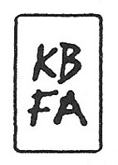
GREGORY HENNEN STATEMENT
I paint to express my love and respect for nature and to cultivate those feelings in others. As a landscape painter I work to create visual imagery of the natural environment and although I use traditional techniques, I try to create works that are contemporary in their design and inspire the viewer to look closely at and even venture into the natural scene depicted.
The organization of space, essentiality of color and quality of light fascinate me. Depicting the natural world in its exactness is not what I do. Instead, my work reflects what I see and how I feel over time. I generally develop a painting from several small drawings worked on location.
By using a palette of close tonalities the objects and surrounding space along with a carefully planned composition result in an all over patterning of color and shape that at times verges on abstraction.
Each piece is about a landscape, not of a landscape as it does not necessarily depict an exact site or location. Finished paintings are often composites of several images that have evolved from a realistic portrayal to a more simplistic interpretation.

