We've All Gone to Look For America
March 20 - May 1, 2021
David Konigsberg, Thomas Sarrantonio, Francis Sills, Sophie Treppendahl
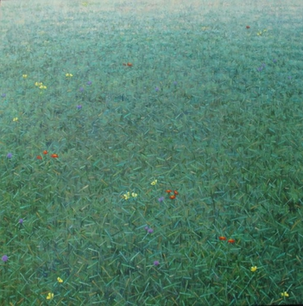 | Thomas Sarrantonio  Community, 2015  oil on linen  42 x 42 inches | $8,000.
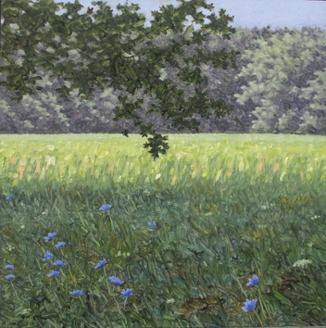 | Thomas Sarrantonio  Field Study July 24, 2020, 2020  oil on panel  12 x 12 inches | $900.
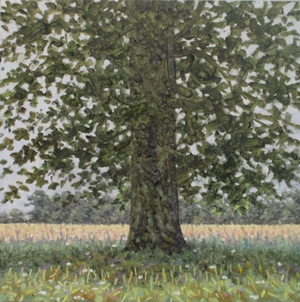 | Thomas Sarrantonio  Field Study August 13, 2020  oil on panel  12 x 12 inches | $900.
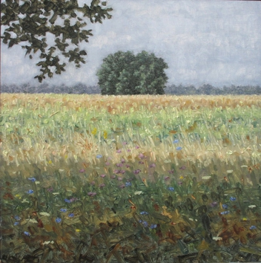 | Thomas Sarrantonio  Field Study July 31, 2020, 2020  oil on panel  12 x 12 inches | $900.
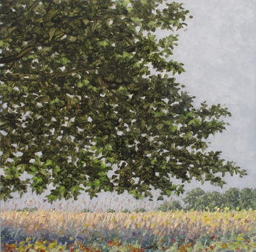 | Thomas Sarrantonio  Field Study September 18, 2020  oil on panel  12 x 12 inches | $900.
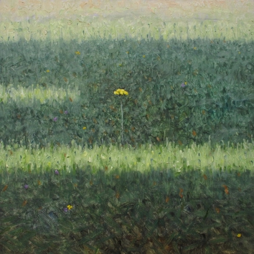 | Thomas Sarrantonio  Field Study July 22, 2020, 2020  oil on panel  12 x 12 inches | $900.
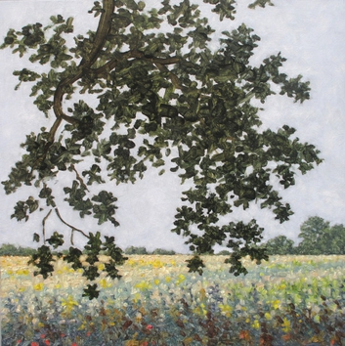 | Thomas Sarrantonio  Field Painting September 15, 2020  oil on panel  12 x 12 inches | $900.
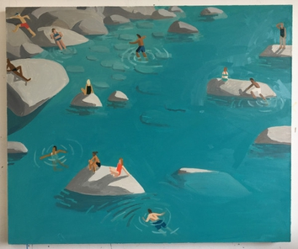 | Sophie Treppendahl  Swimming in the Yuba, 2021  oil on canvas  40 x 48 inches | $5,500.
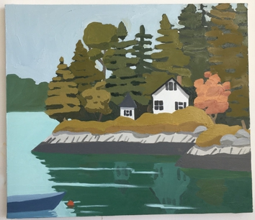 | Sophie Treppendahl  Sheep Island, 2021  oil on canvas  22 x 30 inches | $2,200.
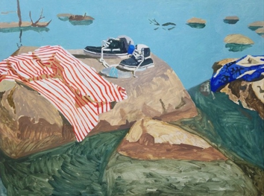 | Sophie Treppendahl  River Stripes, Afternoon, 2018  oil on canvas  36 x 48 inches | $4,000.
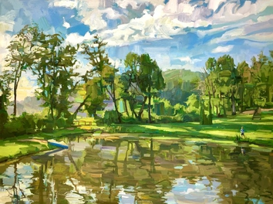 | Francis Sills  Down at the Pond, 2021  oil on linen  36 x 48 inches | $10,000.
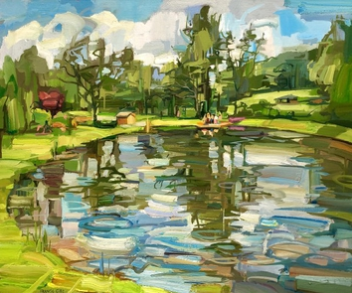 | Francis Sills  Pond at the Farm, 2021  oil on linen  20 x 24 inches | $3,600.
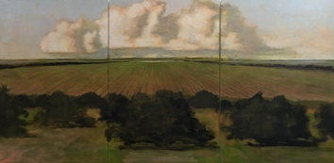 | David Konigsberg  From the Orchard, Evening (triptych), 2020  oil on canvas mounted on panel  60 x 120 inches (triptych) | $24,000.
Please visit our website KBFA.com or inquire for images and information.
SERVICES
Complimentary in-home or in-office consulting.
Artwork is available on an on-approval.
Delivery and installation services.

