Flowers for Friends
new paintings by Melanie Parke
May 21 - July 3, 2022
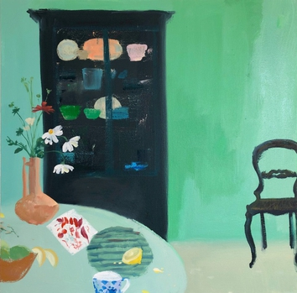 | The Margarete, 2022  oil on canvas  30 x 30 inches | $4,300.
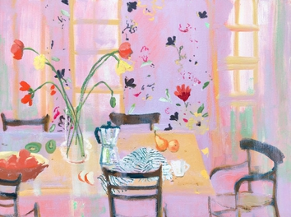 | Hummingbird Mint, 2022  oil on canvas  30 x 40 inches | $5,000.
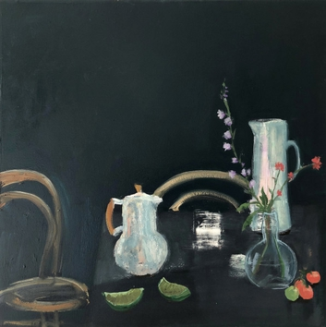 | Assam, 2021  oil on canvas  30 x 30 inches | $4,300.
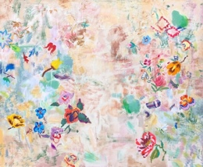 | Crochet, 2021  oil on canvas  48 x 58 inches | $9,200.
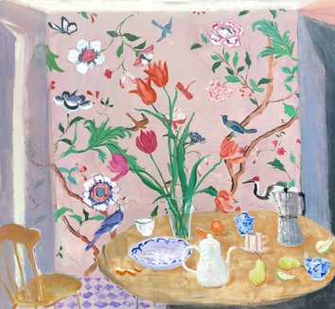 | Evening Rose, 2021  oil on canvas  48 x 52 inches | $8,800.
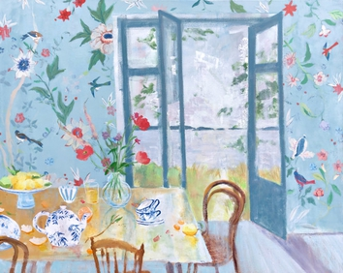 | Wedgewood, 2021  oil on canvas  48 x 60 inches | $9,400.
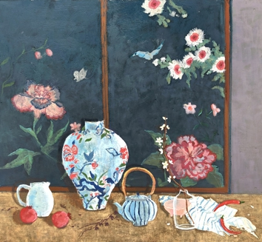 | Tea and Pepper, 2021  oil on canvas  44 x 48 inches | $7,400.
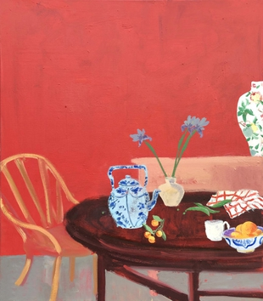 | The Red Salon, 2021  oil on canvas  40 x 35 inches | $5,700.
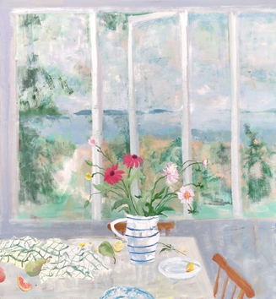 | Island Pears, 2021  oil on canvas  52 x 48 inches | $8,800.
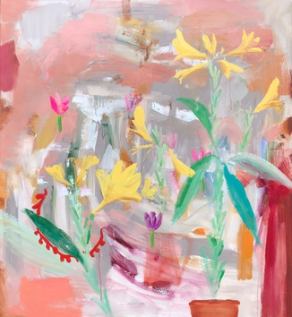 | Prima Porta, 2021  oil on canvas  48 x 52 inches | $8,800.
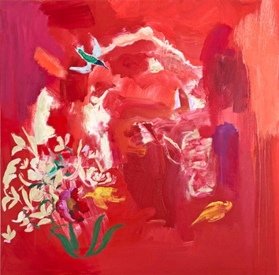 | Poppy Seed, 2021  oil on canvas  36 x 36 inches | $5,200.
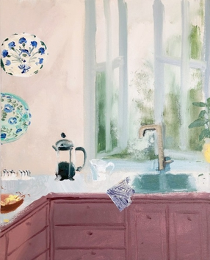 | Aztec Mocha, 2022  oil on canvas  20 x 16 inches | $2,400.
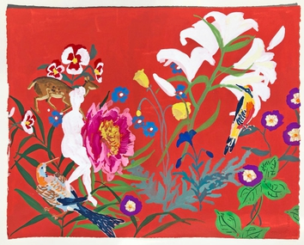 | Red Fawn, 2020  gouache on paper  16 x 20 inches (unframed), 20.75 x 24.75 inches (framed) | $1,200.
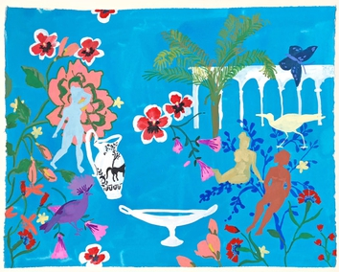 | Crown Bird, 2020  gouache on paper  16 x 20 inches (unframed), 20.75 x 24.75 inches (framed) | $1,200.

Kenise Barnes Fine Art represents more than fifty artists.

Please visit our website KBFA.com or inquire for images and information.

SERVICES
Complimentary in-home or in-office consulting.
Artwork is available on an on-approval.
Delivery and installation services.

