Old Versus New: Victorian Home Gets Modern Update

The renovations create a unique juxtaposition of design and architecture.
BY ANDREA BARBALICH
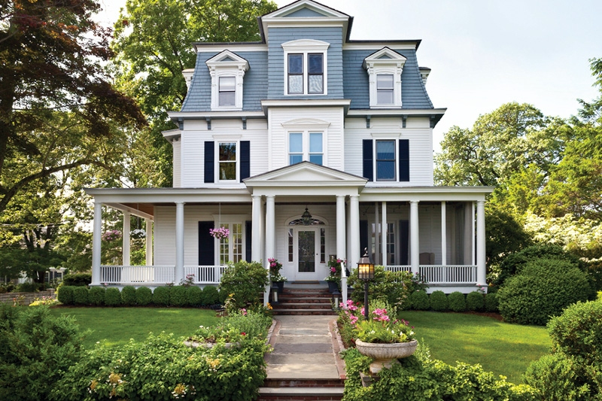
The exterior of the Victorian home.
PHOTOGRAPHY BY GROSS AND DALEY PHOTOGRAPHY
The Pinchin family’s three-story Victorian home overlooking Long Island Sound in Larchmont says “traditional” —on the outside, that is. But a look inside reveals something else altogether: a funky, eclectic interior that’s been reimagined for 21st-century family living.
“It’s not what you expect when you open the front door,” says Robert Keller, principal of Keller/Eaton in Mamaroneck, the architect who oversaw the six-month renovation. “But that’s what makes it so exciting and interesting.”
Keller, working with homeowner Gillian Pinchin— herself the proprietor of her own interior design firm, Wondernose—made the most significant changes to the third floor, which comprised five small maids’ rooms, each one leading to the next. By opening up those spaces and adding on to a two-story addition from 50 years ago, Keller achieved what the family desired: a spacious master suite encompassing a bedroom, bathroom, dressing room, his-and-hers offices, and a deck looking onto the water.
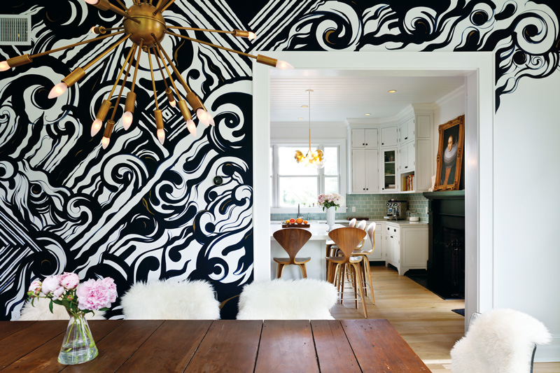
The homeowner used a graffiti artist to create the elaborate mural in the dining room
“The goal was to take spaces that were not used for more than having a housekeeper stay in them and turn them into functional, usable spaces that are pretty and that work for someone in today’s lifestyle,” Keller says.
Making the master suite feel private for the parents without cutting it off from their three children under the age of 10 presented one of the project’s trickier challenges. The solution came in the form of a 2-inch-thick, 400-pound walnut door at the top of the third-floor stairway. Made by Pinchin’s father, a hobby craftsman, it slides on casters, like a barn door.
“It’s just stunning,” Pinchin says. “It slides smoothly and quietly across the entranceway and back.” When the couple want privacy, it stays closed. Otherwise, it’s open, and the third floor feels contiguous to the rest of the house.
Down one flight, the second floor includes three bedrooms and a bath for the children, plus a guest room, bath, and laundry room. On the first floor, a modern island was added in the traditional kitchen. And instead of a formal living room, Pinchin designed what she calls “the grown-up room"—a calm space, with two chaises that can be kept separate or pushed together, where she and her husband can relax with a glass of wine at the end of a busy day. In the basement, Keller created a bedroom, bathroom, mudroom, and gym—“all of which was done in clean, simple, functional style,” Keller says.
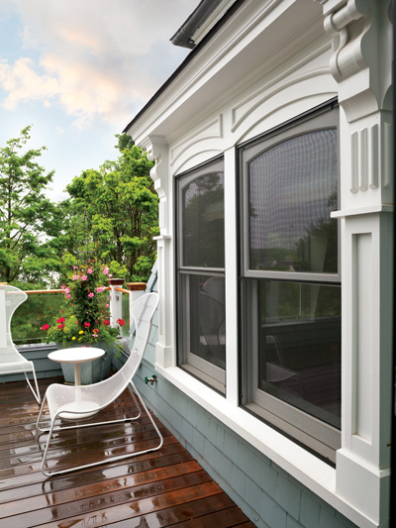  The deck that looks out onto the water. | 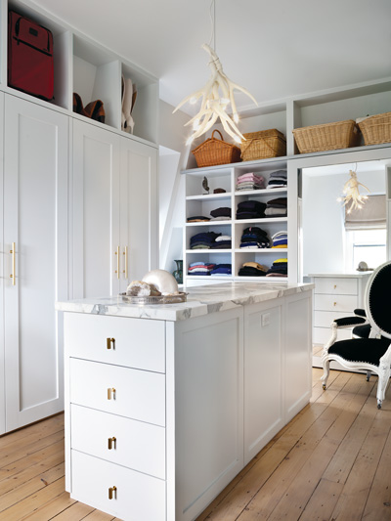  Master closet offers plenty of storage, style
When it came time to design the interior, Pinchin had every wall painted white except for a few accent walls. “That allows one or two pieces in the room— the artwork or furniture — to really pop,” she says. “It’s sort of a gallery approach but in a livable, modern, fun way.”
The most striking “pop” in the entire house is undoubtedly the graffiti wall in the dining room. “I found a gallery in New York City that represents graffiti artists and asked the owner if he knew anyone who would do a commission,” Pinchin recalls. She hired an artist from San Francisco to come to Larchmont to paint for a few days. She wanted spray paint, but he convinced her that although that works when you’re looking at the side of a building from far away, it might not be the best choice in a room where you’re sitting at a table three feet from the art. So he used traditional paint, still achieving the “sloppy” look of graffiti, working the children’s initials into the wall.
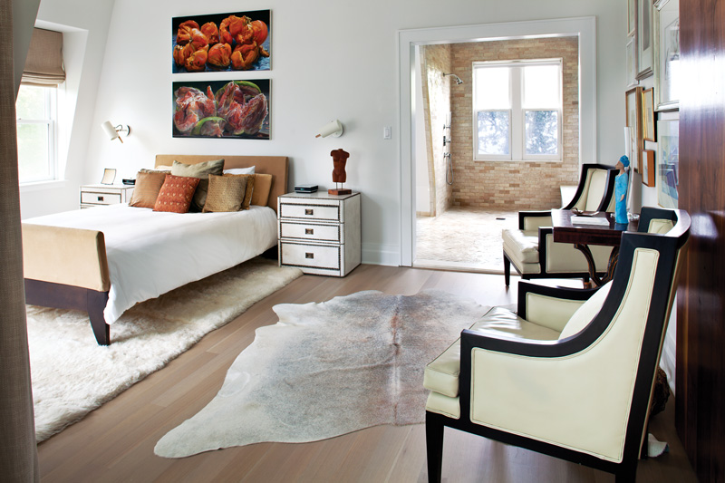
The master bedroom.
Pinchin is thrilled with it. “It’s a crazy wall,” she says. “But the rest of the room is quiet, with my grandmother’s midcentury table and console. I love that contrast.”
That’s what makes the entire project succeed, according to the architect. “You feel the vibe as soon as you walk in, because of the surprising contrast between the old exterior of the building versus the modern interior,” Keller says. “That’s what the whole house is about.”

Surprises in Every Room
“My style is to start with white walls and then add a couple of elements that will really sing,” says homeowner and designer Gillian Pinchin. Here’s how she did it.
In the master bedroom:
The artwork over the bed (paintings of a grapefruit and tomato, purchased at KBFA in Larchmont) pops in the otherwise neutral room.
In her office:
Everything is white except the artwork, including a piece Pinchin painted herself and the zebra-skin chair.
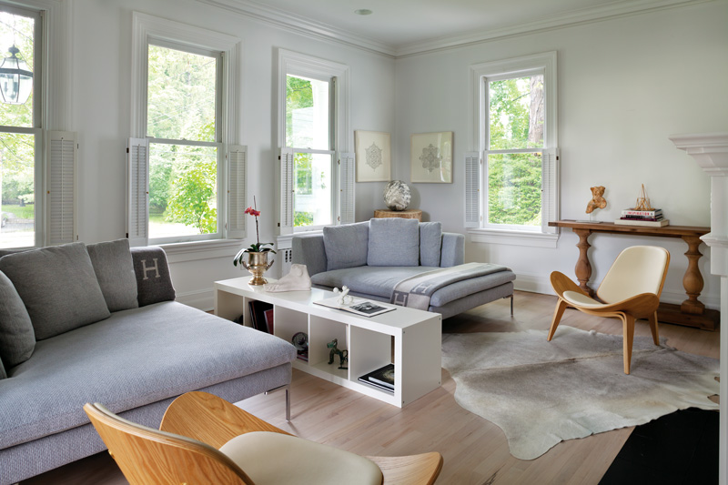
High and low furnishings were used together to create a modern yet cozy living space for the family.
In the kitchen:
The modern island and bubble chandelier are juxtaposed with the reproduction of an old master’s painting and the green subway tile.
In the dining room:
In the house’s most surprising contrast, a black-and-white graffiti wall lives beautifully with midcentury furniture that belonged to Pinchin’s grandmother.
In the “grown-up room”:
The soothing space features a standout piece of art above the mantel, a lenticular image of a ballerina purchased in Italy. “As you look at it, the ballerina twirls,” Pinchin explains. “It’s not a static image.” Another fun contrast in the room: Luxe B&B Italia chaises with an Ikea shelving unit in between.

