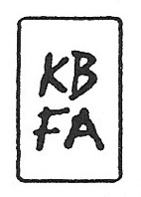DAVID COLLINS STATEMENT

By layering geometric planes and simple patterns on fields of rich color, I strive to convey depth, movement, and a shifting sense of place using the formal elements of painting. In the paintings, structures develop suggesting folded paper, fragments of wings, domestic dwellings or industrial buildings. I draw from childhood recollections of homes, construction sites in 1970s Dallas and time spent in hangars visiting my father’s workplace. Planes of color crop up to create floors, wall-like surfaces, eaves and overhangs. Silhouettes evoke cranes, cables, and overpasses. However, these architectural notions do not remain whole, they fracture and fall away to reveal other chambers or the outside world. A simultaneity of interior and exterior space puts the depicted in the in-between, the liminal. This falling away opens up the paintings to a dynamic landscape with a sense of forces moving in many directions at once. Like the environs of my Midtown Manhattan studio, with its demolition and construction of buildings in the midst of mammoth skyscrapers, my paintings also reveal internal structure and order amidst the chaos. Despite the shifting and multitudinous spaces, the paintings ultimately resolve achieving balance and stillness.