The CT Project Space

Moya Aiken
September 14 - November 2, 2019

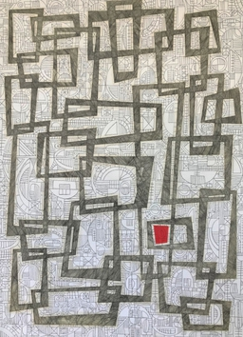 | Moya Aiken  Is It That Obvious? 2018  oil, graphite, and pastel on paper  24 x 17 inches (unframed), 28 x 21 inches (framed) | $ 3,800
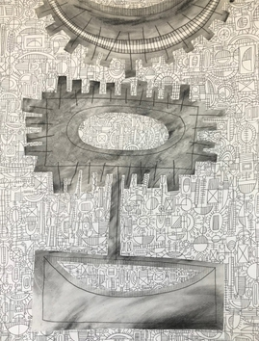 | Moya Aiken  Neck Laced, 2019  oil and graphite on paper  24 x 18 inches (unframed), 28 x 22 inches (framed) | $ 2,900
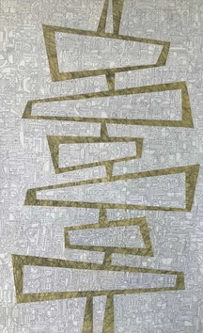 | Moya Aiken  I'm Busy, 2019  oil and graphite on paper  44 x 28 inches (unframed), 48 x 32 (framed) | $ 5,600
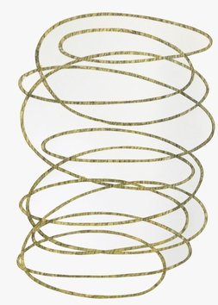 | Moya Aiken  Does it Ever End?, 2018  oil and graphite on paper  24 x 23 inches (unframed), 28 x 27 inches (framed) | $ 3,400

Please inquire for additional available artwork by Moya Aiken

