The Philosophy of Tea - new paintings by Melanie Parke
June 19 - August 1, 2020

The Philosophy of Tea, 2019  oil on canvas  52 x 58 inches | 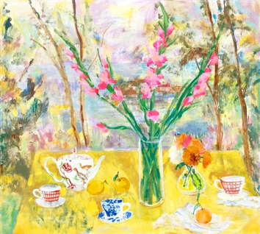 | $9,000.00
Before You Thought Spring, 2020  oil on canvas  40 x 30 inches | 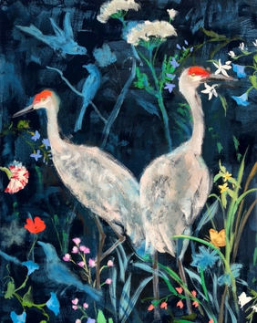 | $4,600.00
Peachy, 2019  oil on canvas  42 x 38 inches | 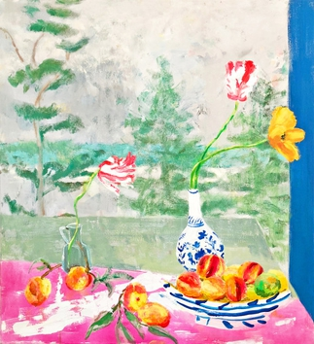 | $5,600.00
Arezzo Garden Square, 2019  oil on canvas  40 x 30 inches | 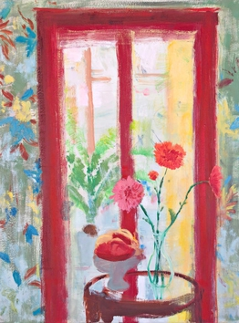 | $4,600.00
Blue Wren, 2020  oil on canvas  30 x 30 inches | 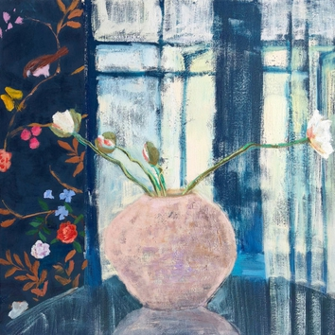 | $3,900.00
Willow Willow, 2019  oil on canvas  32 x 48 inches | 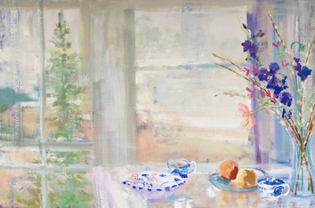 | $5,600.00
Nicae, 2019  oil on canvas  40 x 44 inches | 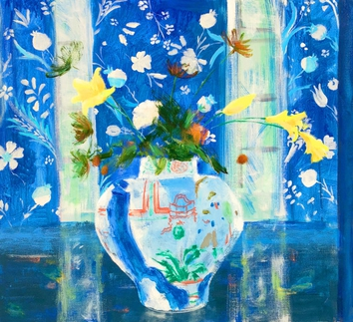 | $6,000.00
Shoreline Posey  oil on canvas  48 x 72 inches | 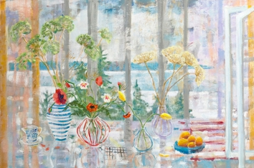 | $9,000.00
Gladiola Pine, 2019  oil on canvas  48 x 52 inches | 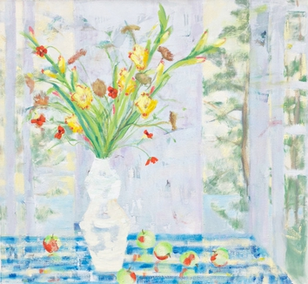 | $8,000.00
Arezzo Morning, 2020  oil on canvas  36 x 36 inches | 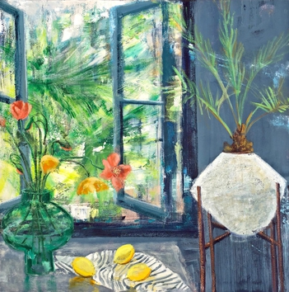 | $4,600.00
Late August Pine, 2019  oil on canvas  36 x 36 inches | 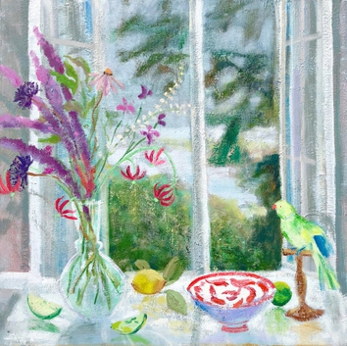 | $4,600.00
The Flower of My Secret, 2020  oil on canvas  48 x 60 inches | 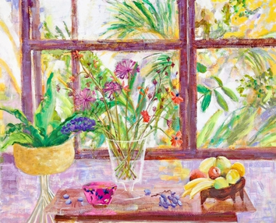 | $8,500.00
Kenise Barnes Fine Art has locations in Larchmont, NY and Kent, CT and represents more than fifty artists.
Please visit our website KBFA.com or inquire for images and information.

