A Year in Windows – new paintings by Sophie Treppendahl
June 19 - August 1, 2020

Night Window, 27th Street, 2020  oil on canvas  36 x 30 inches | 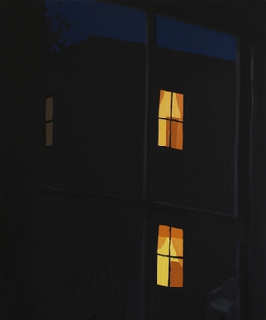 | $3,000.00
Corsicana Studio Study, 2020  oil on canvas  30 x 36 inches | 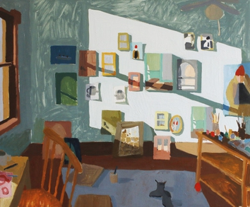 | $3,000.00
Gold Studio Window, 2020  oil on canvas  48 x 36 inches | 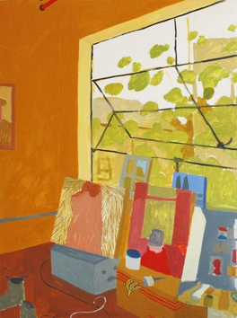 | $5,000.00
Maddie's Wall, 2019  oil on canvas  32 x 40 inches | 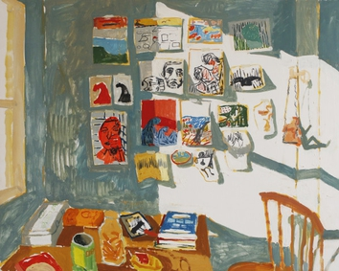 | $4,000.00
Maddie's Desk, 2019  oil on panel  48 x 40 inches | 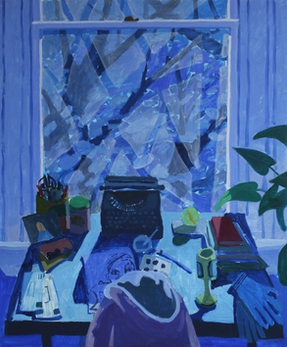 | $5,500.00
View in Chief Michigan, 2019  acrylic and flashe on panel  20 x 16 inches | 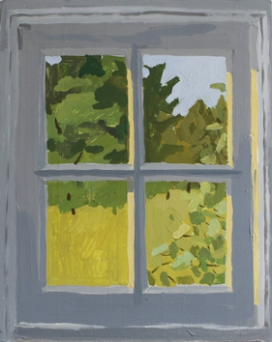 | Sold
Wassaic Studio Window, 2019  acrylic and flashe on panel  16 x 12 inches | 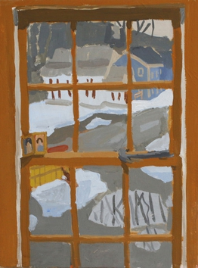 | Sold
Corsicana Window, Pink Sky, 2019  acrylic and flashe on panel  12 x 16 inches | 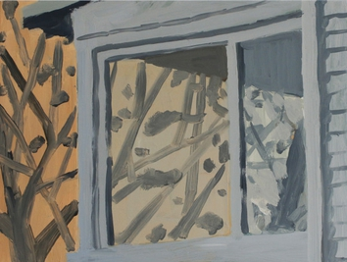 | $1,500.00
Window Shadows, 2019  oil on panel  26 x 32 inches | 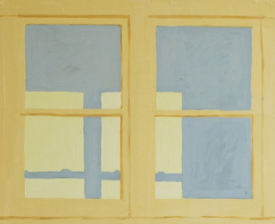 | $2,200.00
Corsicana Third Floor, 2019  acrylic and flashe on panel  24 x 18 inches | 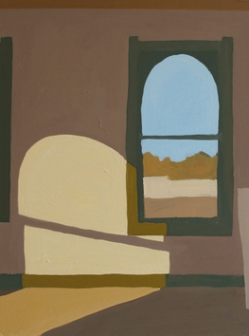 | $1,200.00
Corsicana Window Study, Pink Sky, 2019  acrylic and flashe on panel  24 x 30 inches | 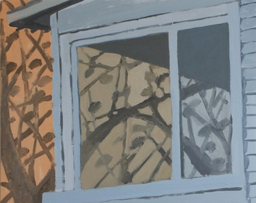 | $850.00
Night Window, Monticello Avenue, 2020  oil on canvas  48 x 36 inches | 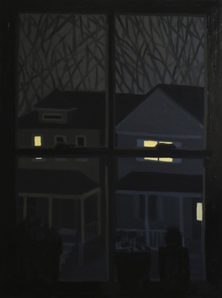 | $5,000.00
Corsicana Stairwell, 2020  oil on panel  40 x 32 inches | 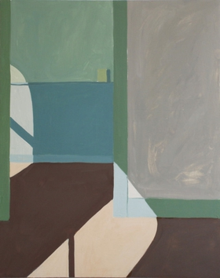 | $4,000.00
Yellow Window in Corsicana, 2020  oil on canvas  24 x 18 inches | 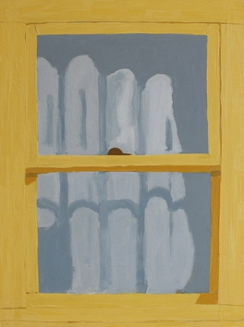 | $1,200.00
Kenise Barnes Fine Art has locations in Larchmont, NY and Kent, CT and represents more than fifty artists.
Please visit our website KBFA.com or inquire for images and information.

SERVICES
Complimentary in-home or in-officeconsulting.
Artwork is available on an on-approval.
Delivery and installation services.

