Wednesday, November 24, 2010

Lorraine Glessner: Philadelphia
LYNETTE HAGGARD'S WEEKLY ARTIST INTERVIEW

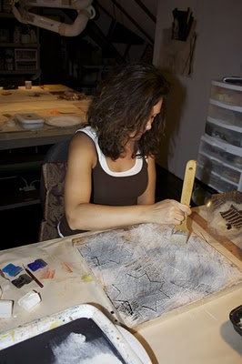
Lorraine Glessner in her studio

Lynette Haggard (LH): Where did you grow up and what (if any) were there any early influences on your work?
Lorraine: I grew up in the seventies where there was pattern and tactility everywhere from shag carpet to shag toilet seats to flocked wallpaper to my mothers dress. My great grandmother was a professional seamstress-she sewed evening and bridal gowns for the rich and famous. My mother was also a seamstress who sewed all of our clothes, all the curtains in the house, the upholstery, etc. I learned to sew at age 4 and got my first sewing machine at 5 and used it to sew doll clothes. We were always making some kind of craft or baking something awesome.
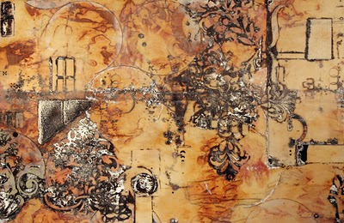
Desert 2
LH: Where do you live now?
Lorraine: In a suburb just outside of Philadelphia, Pennsylvania.

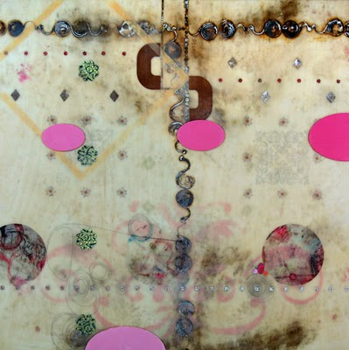
Sixth St. Fake Daisies
LH: Did you receive any formal art training?
Lorraine: I have a BS in textile design from Philadelphia University, an associate’s degree in computer graphics from Moore College of Art & Design and an MFA in fibers from Temple University, Tyler School of Art.
LH: At what point in your life did you become interested in making art?
Lorraine: I was 15 when I decided that I wanted to become a professional artist.
LH: Can you describe a bit about your work in general.
Lorraine: My core ideas involve linking the earth and the body through strong visual patterns and similarities. I focus on natural cycles and the notion of imprinting, staining and marking as it relates to birth through to death and decomposition and the effect of this cycle on both the body and the earth’s surfaces.
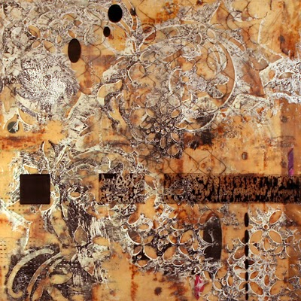
Painted Lady 2

LH: What is your media?
Lorraine:I combine layers of encaustic medium and paint with fabric and found paper that has been subjected to branding and staining. Recorded marks, in the form of rubbings, drawings, and images taken from surfaces of the city are merged together with the stained materials along with my responses to them in paint.
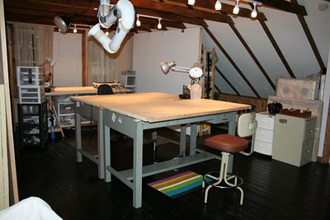
Glessner's studio

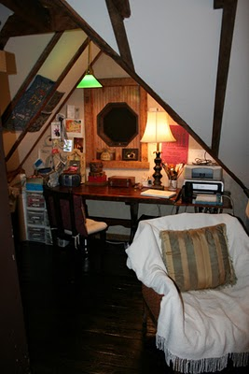
LH: What is your current work about?
Lorraine: The pieces in ‘Down Sixth Street’ series focus on the row homes within the grid of the city, specifically, the concept of home and how the definition of it is relative. I'm struck by the way in which the best people will prevail in even the\ worst circumstances, like the woman who lives next to a boarded up crack house, yet paints her house pink and plants fake flowers! Through often bleak conditions, the desire to illuminate one’s surroundings through the use of decoration, ornament and color is evident in even the most wanting of neighborhoods.
The ‘Rows’ series focuses specifically on the marks of walls of the urban environment. Walls, and what we choose to display on them, whether interior or exterior, have always played a critical role in shaping the identities of the inhabitants of which they embrace. Most cities don’t eliminate, they only get bigger as they build upon and incorporate existing infrastructure. When a row home has been demolished, one can still see the outlines of staircases and rooms along the existing walls between which it once stood. Traces of the lives lived there are reflected in the wallpaper, paint, mirrors and marks of life still left on those walls. Death is just as clearly evidenced through other marked walls by way of sidewalk memorials and written messages to those who have died there. Decorative patterns, marks and messages traced from these walls are combined with found papers and materials through the use of layers of encaustic paint. Through a continuous process of accrual and removal, concealment and exposure, life, death, hope and the determination for renewal is revealed.
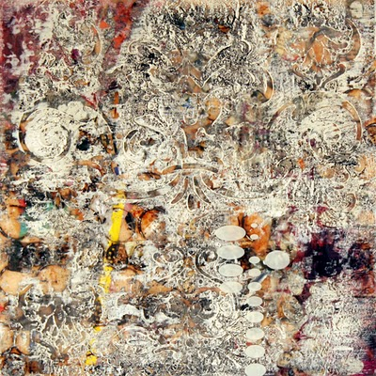
Rows Bank
LH: How do you develop a sense of community with other artists, and how do you support your art colleagues?
Lorraine: I blog about other artist’s work. looking at, thinking about and writing about others’ work has helped me in my teaching and my own art practice as well as enabled me to keep up on what’s out there and to ‘meet’ a lot of awesome people.
I also make it a point to acquire one piece of original art every year-either by purchase or trade.
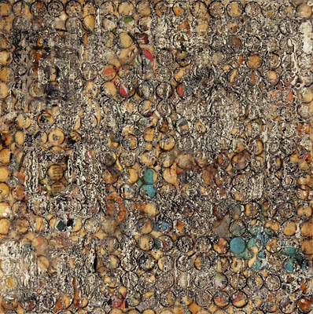
Rows School 2
LH: Do you ever get stuck with your work and how do you remedy this?
Lorraine: Yes, I get stuck A LOT and do a number of things to get out of it. I force myself to draw and I time myself to finish the drawing. Sometimes I’ll do 5-1 minute drawings or blind contour drawings-something to get my arm moving to warm up to paint. my favorite thing to do is look at images and books, I love google earth and i must admit I’m addicted to it, it’s the best remedy for me for getting unstuck.
LH: Do you have particular habits that you think support your art practice?
Lorraine: Some form of exercise, reading and writing everyday.
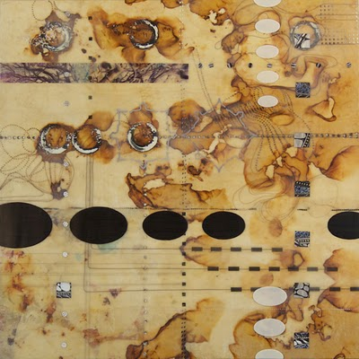
Sixth Window
LH: What are you reading right now?
Lorraine: Well, these are the books currently in the stack by my bed. I read a chapter here and there and then I rotate. Ornament: a Modern Perspective by James Trilling, Maps: Finding Our Place in the World by James Akerman, Vision and Art: the Biology of Seeing by Margaret Livingstone, Symmetry Comes of Age by Dorothy Washburn, The Artists Guide to Public Art by Lynn Basa, the current issue of Art in America.
LH: Do you have other jobs other than making art?
Lorraine: I’m an assistant professor teaching in the fiber department at Temple University, Tyler School of Art. I also teach private workshops once a month, lecture and teach workshops elsewhere as well. In addition, I’m in the process of opening an Etsy store where I will sell mini encaustic paintings, my special recipe encaustic medium and other hand made items. I write for two blogs and I’ve also just started writing a book which combines markmaking processes and techniques with encaustic and fiber.
LH: Where would you like to be in 5 years as far as your art making?
Lorraine: I have a list of goals that involve all aspects of my life, but because art is inextricably enmeshed with my life, a lot of what’s on my list involves art. These are life goals, I can’t put time limits on these things-too much pressure! Some things I would like to do: write a successful book, complete 5 residencies (at least 2 abroad), win a substantial grant, hike as close as I can to an active volcano, visit and spend at least a month in Australia, Hawaii, Japan, Iceland, Ireland, Scotland, Italy, Africa (not necessarily in that order), teach creative workshops abroad, win a public art commission, contribute to my community more by volunteering either in an art related or non-art related way, be represented by a gallery or have a substantial show in my hometown of Philadelphia, Pa., be represented by a gallery or have a substantial show in NYC and/or LA, operate a successful small business.
LH: Do you have any upcoming shows that you'd like to mention?
Lorraine: I frequently update show and workshop information on the right sidebar on my blog and on the ‘events’ page on my web site.

