Review: James Gallery collection reveals complex works painted with wax
Follow us: @triblive on Twitter | triblive on Facebook
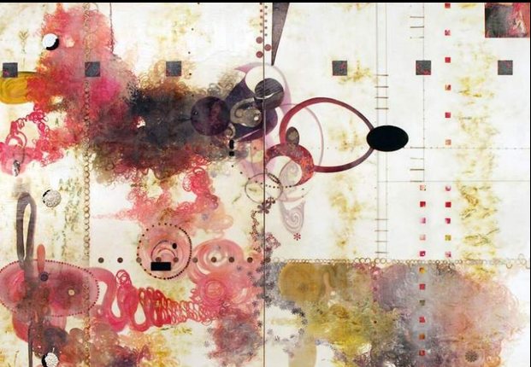
By Kurt Shaw
Published: Wednesday, Dec. 4, 2013, 9:00 p.m.
Painting with encaustic, or hot wax, is a popular art medium; it dates as far back as 800 B.C., when shipbuilders used beeswax with pigment to paint the hulls of their vessels.
So it's no surprise to find an exhibit currently at James Gallery that features the work of 10 contemporary artists working with the medium. But what is a surprise is the wide variety in which each artist employs it.
“Each artist has their own process, technique and visual vocabulary, so the end results vary,” James Gallery director Paul Cicozi says. “What I like about a survey exhibit like this is, it allows the viewer to see how each artist can incorporate that material in their own way, with dramatically different end results.”
Heat is used at every stage of encaustic painting. The paint consists of beeswax melted with pigment and a small amount of resin to impart hardness. It requires working quickly, because the wax begins to harden the moment it leaves its heat source. Light passes through the encaustic paint, creating a captivating, luminous effect.
That's obvious in works like Karen Freedman's encaustic on panel piece “Ruche 0352.20,” which explores symmetrical repetition and the potential to manipulate patterns with color.
An artist from North Wales, a suburb of Philadelphia, Freedman says all of her pieces on display are part of her “Kaleidoscoptical” series, which grew out of an entry into an exhibit for which the theme was the honeybee.
“With that, I decided to interpret the exhibition's theme by using a hexagonal repeat, which was inspired by the beehive and its internal structure of cells, the honeycomb,” she says. “Even the title of each painting reflects this inspiration. Ruche is the French word for beehive.”
The remaining artists employ a wide range of additive and subtractive techniques, including pouring, fusing, inscribing and embedding.
For example, Shadyside artist Stephanie Armbruster's piece “Signs & Premonitions” is a large-scale semi-abstract work made of encaustic on birch panel. Part of her most recent series, “The History of Walls,” it features two portraits of the same person who is part of a small cast of characters who occasionally make a repeat appearance in her work, each with their own purpose and mythology.
“I have no idea who the gentleman in the photos is, which is why I've chosen to protect his identity. I refer to him only as ‘The Guy,' and he seems to be an agent of change, always appearing in my work at times of conceptual or physical transition,” Armbruster says.
With much of the rest of the work having subtractive qualities, this piece is largely about acts of interpretation, anonymity and authorship. To that end, it is built from about 15 layers of translucent wax, hinting at the presence of language, but intentionally leaving the piece otherwise devoid of context, anonymous and open to interpretation.
Similarly elusive, Christine Aaron of Larchmont, N.Y., displays “Vestige,” a lithographic monoprint in encaustic on patinated steel.
Addressing themes of memory, and the passage of time, the piece is one of a series that uses tree imagery as symbolic of the human experience of memory.
“Trees mark time,” Aaron says. “They serve as a metaphor for the cycle of life, symbols of dormancy and growth, strength and renewal. Trees hold the record of their lives in their rings. These inner marks remain hidden from view in the way that humans hold the physical, mental and emotional marks of personal experience within.”
Aaron says the use of encaustic in combination with other materials enables her to embody these concepts. “Printmaking and encaustic allow me to develop through layering much the way human perception and memory is formed, and conveys a visual sense of the archeological act of recollection,” she says. “‘Vestige' is on steel, which I have ‘aged' and rusted so that time itself becomes an integral part of the piece.”
Nature is evoked, as well, in “The Space Between,” a triptych by Jane Guthridge of Denver. An encaustic and archival inkjet print on translucent mulberry paper, the piece is meant to evoke the experience of nature, Guthridge says. “Not so much how it looks, but how it feels,” she says.
“In these works, I use encaustic and the language of abstraction to try and evoke the experience of nature,” she says. “Encaustic has a unique optical effect on light and color that allows me to create a contemplative experience.”
Catherine Nash of Tucson, Ariz., shows the only three-dimensional pieces in the exhibit. Her “Eclipsis Lunar,” for example, is a mixed-media assemblage and encaustic painting in an antique box that includes a chalk drawing of a lunar eclipse diagram.
“This is a work inspired from witnessing a full lunar eclipse,” Nash says. “I first made a cabinet out of an old box and wooden panels using vintage hardware. Encaustic was painted into the bottom of the box and the constellation scragfitto (scratch drawings) were filled with white oil stick, the surface wiped clean.”
Pages of handmade paper painted with walnut ink on the inner doors add a finishing touch. And cut branches were fitted into the box and painted with encaustic. To top it off, Nash created two versions of a lunar eclipse cut from mica sheeting and adhered them inside a removable, antique compact case. “Finally, using white wax pencil and chalk, I copied a circa 1552 diagram of a lunar eclipse on an old school slate,” she explains. The result is alchemical, a truly transformational piece.
No less unusual in terms of materials, Philadelphia-based Lorraine Glessner's “Under the Pink” is a real standout for its inclusion of horse and human hair. Investigating the “volatility and vulnerability between the earth and humankind and between humans themselves,” Glessner says this piece contains “liberal sexual undertones” within the colors and imagery that are “an investigation into romantic relationships — the freshness, romance and obsessiveness in the beginning of the relationship and the ups and downs, trials, breakups and reconciliations throughout the remainder of the relationship.”
Finally, Santa Fe artist Paula Roland's “Language of Beauty VII,” an encaustic monotype on Shikoku paper, is about the most free-flowing and organic piece in the exhibit.
“I purposely use processes that are slightly out of my control,” Roland says. “With encaustic monotypes, there is an aspect of performance. Acting, creating marks and shapes using dancelike whole-body movements, and reacting — accepting and utilizing the fluid wax and pigment forms that are often a surprise. The molten-wax monotype provides a connection between intuition and cognition.”
“The process never fails to get me to a deeper place, to reveal my innermost feelings and interests without being didactic. In this case, the revelation was beauty, accepting beauty, and mapping and deciphering its personal language for me as I worked. It has been a journey that requires the acceptance and relevance of beauty as an important element in my art, defining for myself what it is and what it is not.”
Read more: http://triblive.com/aande/museums/5187466-74/encaustic-says-piece#ixzz2qmFNXQ9r
Follow us: @triblive on Twitter | triblive on Facebook

