Daily Nutmeg Food. Arts. People. Events. New Haven.
Arts & Entertainment Food Family City Life Events
Arts & Entertainment Aug 07, 2014
The Thinker
Drink Style Beauty Health Home Travel
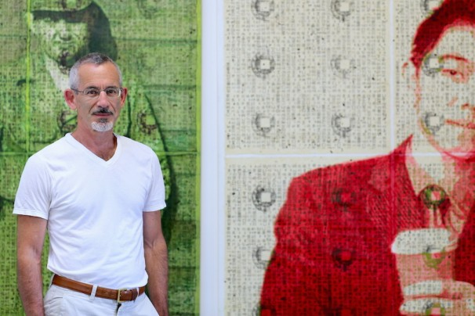

There’s change in the air at painter Stephen Grossman’s downtown studio. With his artist- filled building at 39 Church Street slated for conversion to apartments, he’s in the process of packing up his stuff and moving to new digs.
On the day we meet, many of his works still line the walls. Fittingly, they often communicate a sense of lost history, or what French author Marcel Proust might have called temps perdu— moments both cultural and personal, half-forgotten and altered by time, that Grossman has reclaimed and represented through the perspective of the present.
Among them are pieces from “Luftmentsh,” a series centered around a recurring figure who strikes a mild Mad Men chord. A classic 1960s businessman outfitted in suit, tie and fedora with briefcase at his side, he’s portrayed alone or in groups across a variety of media: graphite drawing, oil on canvas, gouache on paper, encaustic on panel, collage, watercolor. Ranging in size from 8” x 6” to 80” x 48”, all the works have abstract, amorphous backgrounds out of which these characters seem to be arising or into which they’re disappearing, depending on your perspective.
“‘Luftmentsh’ literally means ‘air men,’” Grossman says, “though colloquially, it’s a Yiddish word for ‘someone whose head is in the clouds.’ During the Enlightenment, it came to mean ‘someone who makes their living selling air.’” For Grossman, “selling air” is a good way of describing the business activities of admen like his father, who sold advertising in the 1960s and serves as the inspiration for the series’s central besuited figure.

Even more personal for the artist is a series of recreated photographs. One he’s particularly proud of is Five­boys­1967, a 40-by-60-inch, gouache-on-paper representation of an actual childhood photograph featuring a 10-year-old Grossman with some meticulously groomed playmates. He says it reflects the dissolution of innocence, which had characterized “the world that existed just before the cultural eruption of the late ’60s that we all were about to transition into.” The work is distorted by intricate swirls of muted colors that took him “eight months of 40-hour work weeks” to complete, a process he calls “a form of art therapy.”
To Grossman, the execution behind a work is just as important as its meaning, and during long hours spent on painstaking detail work, he has time to think about the nature of what he’s creating. “I’m always exploring the question, ‘What is a picture?’” he says. “I move between the abstract and the representational. What I like about representational images is that on the one hand, you have the original subject, and on the other, the recreation of that subject—and you struggle with [questions like], ‘How does the artwork represent the subject but also stand as an independent entity?’”
His interest in aesthetics was fueled by frustrations with his early work life. Though he graduated magna cum laude with a B.S. in mechanical engineering from Tufts University in 1979, he quickly found that career track “utterly boring,” and returned to school for a B.A. in architecture from New York’s Cooper Union. “Cooper Union was a school preoccupied with conceptual training, not teaching the nuts and bolts,” says Grossman. “The idea was that a drawing of a building is almost as significant as the building itself.”

As a novice architect, however, he found himself doing more drafting than design. He initially scratched his creative itch by pursuing public art projects, including significant collaborations with New Haven’s Artspace. One of the most notorious was 365 Bales, an installation designed in 2000 for The Lot, Artspace’s outdoor installation space on Chapel Street near Orange. Says Grossman, “The Lot was a very urban, unfriendly space with a brick wall on one side and concrete block walls on two others. I noticed that there were weeds and nesting birds in the concrete block walls, which got me thinking about how nature creeps back in to a city space when it starts to decay. So I wanted, in this parched environment, to create something soft that had greater elements of nature, like the smell of hay.”
His plan was to cover the ground with cedar mulch and build several vertical walls with hay bales, creating a meditative space apart from the surrounding urban environment. But the installation only lasted a single day. “We hadn’t done a very good job of notifying the city’s public safety people,” he says. “They were worried that all the hay would be ignited by someone who, say, carelessly tossed a cigarette butt into the space.”
Though he enjoyed such projects, Grossman later made what he calls “the more practical decision” to establish his own studio. “I wanted to have more control, to do something I could sell to sustain myself,” he says.
His most recent series, “To Dream of Being a Child Again,” is far more freewheeling than what he sees as his sometimes “obsessive” previous work. “The paintings revolve around imagining who I was as a young child,” he says. “They’re about being a 57-year-old trying to imagine the inner life of a 5-year-old.” Keeping in mind, as always, that being a 5-year-old and one’s memory of being a 5-year-old—like any subject and its representation—are two dramatically different things.
Stephen Grossman 39 Church St, Ste 4B (map)—for now info@sgrossman.net www.sgrossman.net
Written by Patricia Grandjean. Photos #1, 3, 4 and 6 by Dan Mims. Photos #2 and 5 courtesy of Stephen Grossman.
About Patricia Grandjean
A former senior editor at Connecticut Magazine, Pat Grandjean is a cultural omnivore who loves everything from Beck and “Doc Martin” to Shakespeare and Quentin Tarantino. She currently spends much of her free time volunteering at the New Haven Animal Shelter and cleaning apartment closets.

