The New Colonialism

SUNDAY, SEPTEMBER 7TH, 2014
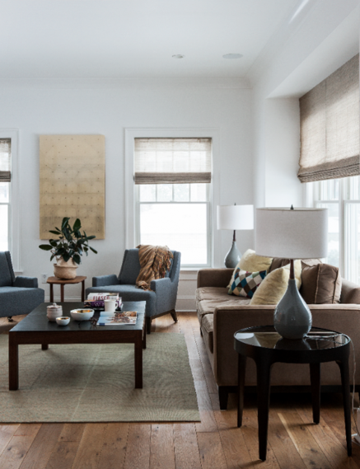
Featured Company: Victoria Kirk Interiors - Location: Larchmont, New York - Project Type: Residence - Project Name: Iden House
Photos by Matthew Williams,matthewwilliamsphotographer.com
By Patrick Sisson
Green construction often hews towards a natural, unfinished look—shades of bamboo and rough-hewn, reclaimed materials that scream eco-chic instead of confidently showcasing alternatives to a played-out aesthetic. When Victoria Kirk began envisioning the future of an old 3,500-square-foot colonial in Larchmont, New York, she focused on fusing modern practices and minimal design without sacrificing the structure’s inherent 1920s charm.
“What I love about the overall aesthetic is that it’s clean, calm, and comfortable,” she says. “The client’s aesthetic was more modern, so the challenge was to create a contemporary look in a more traditional architecture.”
With the help of junior designer Brandi Becker, Kirk didn’t let the home’s subtle color palette, the result of natural dyes, lock her into a traditional green style, instead using splashes of colors and small embellishments to accent the white walls. The calm, confident interior played off the natural materials utilized in the construction and design. Reclaimed LV Wood floors finished with natural wax, hand-woven grass window shades by Hartman & Forbes, and sustainable Pure Kitchens cabinetry with low-VOC paint met the client’s wishes for a healthy, responsible living environment, without sacrificing colonial grandeur. Even the art struck the same balance, exuding quiet personality—a family-room photo by Bastienne Schmidt of a little boy reminded the client of her son, and the Lalani Nanpainting in the bedroom, a hyper-real rendition of a sheet of fabric, reinforced the minimal aesthetic.
Kirk’s clients, a couple with children making their first foray into the ’burbs, raved about the finished home, especially the contemporary kitchen and breakfast banquet and the sophisticated built-ins.
"Not all green design is good design and can present challenges,” she says. “As a society, we have made great strides in improving the ‘health’ of our environment, but sustainability is still a pretty new concept that the design community needs to continually improve upon.”
Tagged with: Bastienne Schmidt • Hartman & Forbes •Iden House • Lalani Nan • Pure Kitchens • Victoria Mark Interiors

