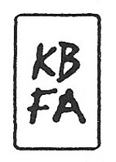
SARAH MOREJOHN STATEMENT

My artistic practice is based on drawing. I am interested in the ways that a drawing, line for line and dot for dot, slips into a lost daydream and becomes an all-consuming conversation. I draw because of its simplicity and intimacy. Rational but also pessimistic person that I am, drawing persuades me that the world is not over, and that there are infinite and seemingly insignificant ways to think and wonder about the world.
My lines resemble water and biomorphic forms. I look at and sketch a variety of images of precipitation and cells, developing my own vocabulary. I am interested in how precipitation shapes the world; how much is lost in its absence or abundance. By drawing I collapse micro and macro ways of seeing, envisioning a dream-like ecology between visible and invisible forces. This year I have been cutting out my work, calling attention to negative space with a blade, and creating a dual sense of the work inhabiting its own world and its potential for growth.

